Rick Benjamins’ intellectual and theological interests are presented here by some short remarks on his books.
- In 1994, Benjamins published his dissertation Eingeordnete Freiheit, Freiheit und Vorsehung bei Origenes, Leiden: Brill, Vigiliae Christianae, Supplements, Volume 28.

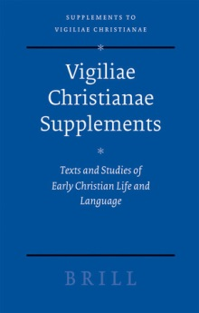

Eingeordnete Freiheit compares Origen's notion of freedom of choice with the concepts of contemporary philosophers. The first chapter deals with the philosophical problem of freedom of choice throughout the history of Greek philosophy. In the second chapter Origen's writing on this topic is assembled, translated, analyzed and commented upon. The comparison between Origen and his contemporaries leads in chapter three to the conclusion that Origen's concept of freedom differs especially from the philosophical perspective, since human freedom does not stand in opposition to the inevitable pattern of the pronoia or heimarmene but to Gods care for every individual. Chapter four shows that the notion of oikonomia in Christian theology is based on the concept of providence in Origen. Oikonomia accounts for the interaction between God and human beings in Origen’s theology and denotes the temporal order in which human beings are raised up to the unspeakable or eternal, both collectively in the Heilsgeschichte and individually by the pedagogy of the Logos.
- In 1997, a reflection on Christian faith in modern or postmodern contexts followed. Mocht God bestaan: Het christelijk geloof ter verantwoording, Baarn: Callenbach. (‘If God were to exist: Christian faith called to account’).
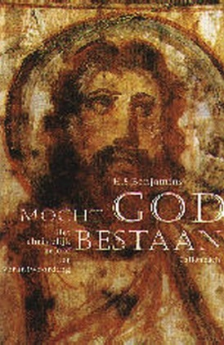
This book was an attempt to be a theologian instead of a patristic scholar. It takes as its starting point the idea that human beings strive for happiness in the context of righteousness. Postmodern society enhances human beings to present themselves as independent and autonomous individuals who deny their vulnerability and dependency. It thereby provokes them to escape from themselves. The notion of ‘God’ might provide us with a different perspective on ourselves, as it clarifies that we are not God. It could help us to receive our existence as a gift, with which we are allowed to operate freely. It will be right and consequential, however, to freely oppose destruction, since God grants being to all and calls for its flourishing. The center stage of Christ in Christian faith reflects the idea that human life can be a manifestation of God, even though human beings are not God and God cannot be grasped. In pantomiming, an object is groped from the void. Likewise, an absent God can be presented by human life if it is lived in dedication to God. In Christ, humanity, lost by destruction, is recovered.

- In 2002 Benjamins and Hofstra composed an introduction and a short manual to prof. Dingemans’ study ‘De stem van de Roepende’. Rick Benjamins en Sita Hofstra, Een vertolking van de stem: Handreiking bij Dingemans’ stem van de roepende, Kampen: Kok.

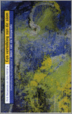

In 2000, Gijs Dingemans – a teacher of Benjamins and Hofstra – published his thoroughgoing presentation and re-figuration of Christian faith. Dingemans took a panentheistic stance, influenced by modern hermeneutics and process-theology, and described his work as pneuma-theology. The introduction by Benjamins and Hofstra aimed at making his study accessible to interested laypeople, especially to be used in local church community groups.

- In 2003 Benjamins presented his study Een zachte soort van zijn: Drie manieren om van God te denken: Plotinus, Rilke, Jonas. Budel: Damon. (A tender way of being: Three ways to conceive of God).

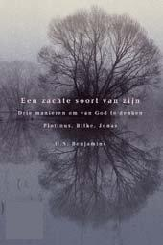

In post-Christian society we have taken our leave of the God up-there, which leaves us either speechless about transcendence or stammering with obsolete language. Yet, this situation may invite us to draw on alternative images of God that may be telling and meaningful today. Even though God is beyond the images, we need them as the means by which a reality is opened up to us and God may give Godself to us. There is no guarantee for these images to really communicate God except for our own subjective consent, however, and this calls for our addressability and honesty.
In Plotinus, the metaphysical structure of the world corresponds to the structure of our mind. The way upward, therefore, is a way inward: to soul, nous and One. One is beyond all, beyond division and distinction, ineffable. But nothing can exist without participation in the One, having the One present tot itself, thereby being a unity. Likewise, nothing can be particular, determined or distinct, without participation in nous, which is the platonic world of ideas. Vice versa, the world of ideas is present in our nous. Finally, nothing has movement or life without soul. According to Plotinus, we are never cut off from the spiritual world of the divine, which is present to our mind. Under the surface we are in touch with all beings that are expressions of the One, but yet, the One is beyond all, most near and far away.
In the Stundenbuch (Book of Hours), the German poet Rilke starts a cycle of poems in the persona of a Russian monk and a painter of icons, who wants to complete the world by contemplation. In these poems, God appears to be a God of darkness and silence, underneath the earth, who can come to light in the words, images and creations of human beings. These images both present and withdraw God to and from human beings. They are both the means to present and represent God and the screen that stands in their way. God becomes and grows as God is shaped and formed by artists. In the end, God will inherit all the beauty of human production. Yet, the situation is precarious. If we lose contact, God will fall back into darkness. In a state of poverty and modesty, which is receptive and not imposing, we can serve God.
The Jewish philosopher Hans Jonas wrote a book about gnosis, which interested him most in relation to Heidegger’s philosophy; he developed a so called ‘philosophical biology’, and he wrote about ethics and the thread to the planet. At the end of his life, Jonas wrote about metaphysics and theology in two short treatises, Der Gottesbegriff nach Auschwitz and Materie, Geist und Schöpfung: Kosmologischer Befund und kosmogonische Vermutung. According to his conjecture, the godhead disseminates itself completely in the process of becoming, in order to facilitate this insecure process and to receive itself back, enriched by the many experiences in time and history. In human beings, transcendence awakens to itself. Since God invested and incarnated Godself in the history of the cosmos, God put Godself at risk and made Godself dependent on the acts of human beings. Their actions are immortal and remain indelibly in such a sense that they draw a feature in the face of God. That is why human beings are responsible for the being of God, who is not almighty and suffers.
God gives Godself, but is received in various manners, dependent on the concepts human beings bring along with them. A common trait in these very different ways of thought is that God is amorphous. This is even the case in Plotinus, for whom the One is beyond form and structure. In Rilke and Jonas, God receives his form and structure by the words and acts of human beings. This points to a radical interaction between God and human beings, which affects and shapes God as well as humans.

- In order to relate the ‘alternative’ notions of God to theological discourses and to find out, what liberal theology is about, Benjamins undertook a thoroughgoing study of the tradition of modern theology in the Netherlands. Een en ander: De traditie van de modern theologie, Kampen: Kok 2008. (One and other, the tradition of modern theology)

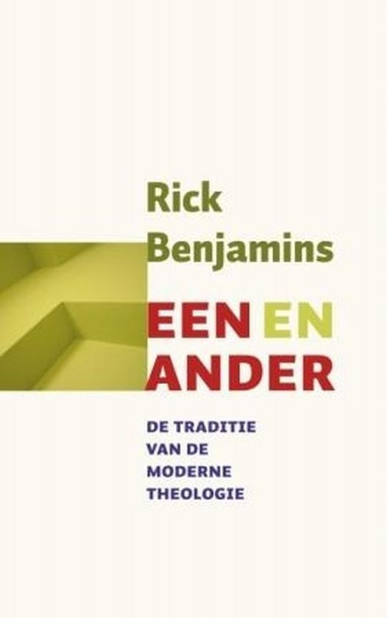

The book starts with a chapter on Jan Hendrik Scholten and Cornelis Willem Opzoomer, who founded the tradition of modernism in the history of Dutch theology rather late between 1840 and 1860. The next chapter focuses on Karel Hendrik Roessingh, a right-wing modernist (1886-1925), who criticized modernism’s monism and optimism, after the movement had lost its momentum. Roessingh went back to ‘dubious’ concepts like sin, repentance and grace to reframe the modern tradition in classical terms. Roessingh was greatly influenced by Ernst Troeltsch and was interested in (and opposed to) the beginnings of dialectical theology shortly before his untimely death. The third chapter discusses the so-called ‘ethical theology’, between orthodoxy and modernism, especially represented by J.H. Gunning (1829-1905). Because of Christ, we learn to understand the moral and divine order of this world, its origin and destination, in personal terms rather than abstract concepts. Human beings may receive Gods revelation as a gift of life, not as a piece of information drawn from Scriptures. Chapter four is on Gerardus van der Leeuw (1890-1950), who is mostly known as a phenomenologist of religion, but developed a complex and intriguing theology as well. Since God manifested him/herself in Christ in this world, the whole world, in nature, art, history and science may refer to God. Van der Leeuw was especially interested in the ‘primitive’ experiences of life in art and religion. In chapter five, the ‘modern anti-modernist’ theologians Heiko Miskotte and Oepke Noordmans are introduced. They were deeply influenced by Karl Barth, but maintained their own interests and developed their own theology independently of each other. Miskotte and Noordmans had a great impact on Dutch theology to such an extent that it almost forgot its pre-Barthian heritage. Whereas modernists and ethical theologians underlined the unity of the world, related to the unity of God, in Miskotte and Noordmans the otherness of God is accentuated. The final chapter is on postmodernism and theology and focuses on language, critique of the subject and radical alterity.
In retrospect, this study offered two important understandings. 1. Pre-Barthian theology, especially in Roessingh and Van der Leeuw, is still important and may be very fruitful for us today. 2. The differences between modern and postmodern theologies run deep; whereas modern theologians accentuate the whole, and the unity of life and life- experiences (and fear fragmentation and meaninglessness), the postmodernists emphasize differences and irreducible alterity (and fear totalitarian traits as a result of conceiving a whole or a totality).
- In 2010 Benjamins composed an anthology of protestant spirituality in the Netherlands at the request of the publisher. Rick Benjamins (samenstelling), Canon van de protestantse spiritualiteit in Nederland, Kampen: Kok.

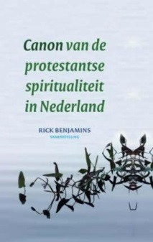

The book contains texts from the modern devotion movement, Christian humanists, the Reformation and ‘Further Reformation’, the Enlightenment, het Réveil (the Awakening), Modernism and a variety of 19th and 20th century movements.
- In 2016 Benjamins initiated and co-edited a book ‘Liberal Christianity’. He was the author of the introduction and some chapters. The book wanted to present a liberal version of the Christian faith in a postmodern context. The book was very well received and reviewed and became a bestseller that was widely used and discussed in groups and Churches. Rick Benjamins, Jan Offringa, Wouter Slob (red.), Liberaal Christendom: Ervaren, doen, denken, Vught: Skandalon.

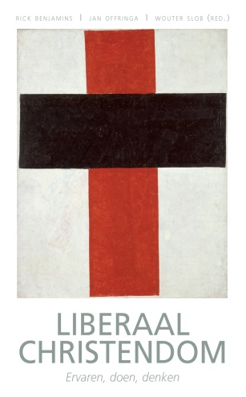
Some basic thoughts functioned as beacons.
After the death of God, we can still recognize God. To have a God is to be touched and called by the vulnerability of other people and to have compassion. God is God, if we let him/her be God.
What transcends us, is among us. That is what ‘incarnation’ means. God can be embodied and realized by human beings.
A true humanity is achieved in recognition of the other, in whom we may meet an image of the eternal one and a human being like ourselves. In this way, faith is directed towards community, opposed to autonomous being. Our own being depends upon others recognizing us.
If charity is key to Christianity, it can never be about its own rightness. It is about the interest of the other.

- In 2017 Benjamins co-initiated ‘The liberal lecture’. The first lecture was delivered by Catherine Keller and in order to introduce her to broader audience, Benjamins wrote an introduction to her theology. Catherine Keller’s constructieve theologie, Vught: Skandalon.

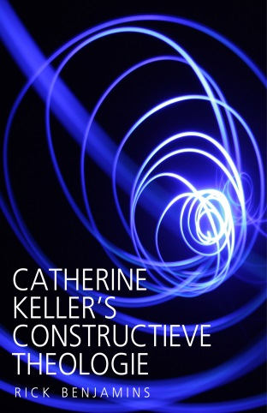

Keller’s theology is of great interest, because of her emphasis on relations instead of self or other. Her apophatic panentheism offers a new way to conceive of the God-world relation and to commit ourselves to the flourishing of the world in which we are entangled.

