**International Conference Registration**

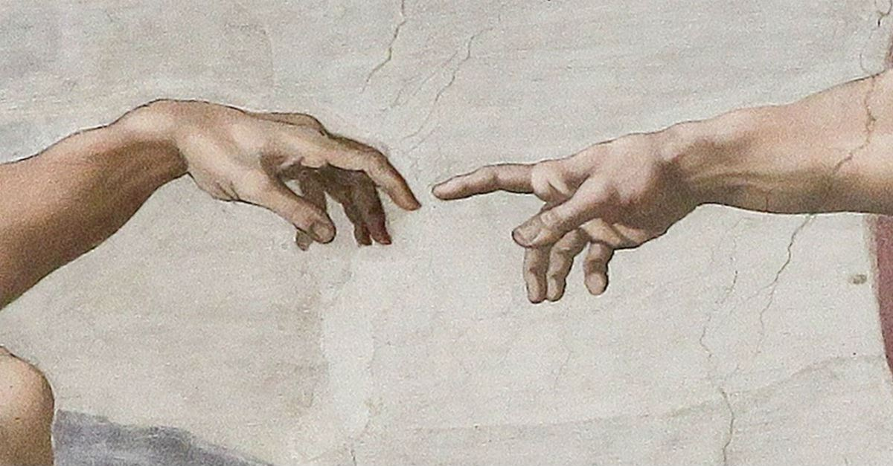

**Imago Dei – 12th Comenius Conference**

**Invitation**

You are cordially invited to attend the 12th Comenius Conference at Pápa Reformed Theological Seminary (Pápai Református Teológiai Akadémia = PRTA), Hungary, between the 20th and 23rd April, 2022. The theme is interdisciplinary in nature and covers a range of disciplinary areas such as biblical theology and anthropology, systematic and practical theology.

**REGISTRATION FORM**

All information supplied will only be employed for the purposes of registration.

|  |  |  |  |  |  |  |  |  |  |  |  |  |  |  |  |
| --- | --- | --- | --- | --- | --- | --- | --- | --- | --- | --- | --- | --- | --- | --- | --- |
| Surname | | | |  | | | | | | | | | | | |
| Given name(s) | | | |  | | | | | | | | | | | |
| Title | | | |  | | | | | | | | | | | |
| Affiliation | | | |  | | | | | | | | | | | |
| Telephone | | | |  | | | | | | Mobile |  | | | | |
| Email | | | |  | | | | | | | | | | | |
| Special requirements (e.g. diet or disability) | | | | | | | | | |  | | | | | |
| Lunch | | 21st April | | |  | | | 22nd April | |  | | 23rd April | |  | |
| Dinner | | 20th April | | |  | | | 21st April (Banquet) | |  | | 22nd April (Excursion with dinner) | |  | |
| I wish to request accommodation at PRTA (15 €/person/night) for the following nights: | | | | | | | | | | | | | | | |
| 20th  April |  | | 21st  April | | |  | | 22nd  April |  | 23rd  April |  | | 24th  April | |  |
| I am a student | | | | | | | | | | | |  | | | |
| Basic conference fee | | | | | | | 4 days  80 €:  60 €:  Daily  25 €:  20 €:  Please indicate number of days | | |  | Student (4 days) 30 €:  Daily (student) 10 €:  Please indicate number of days | | | |  |
| I would like to use the car park at PRTA | | | | | | | | | | |  | | | | |
| I need transport from Pápa railway station to PRTA | | | | | | | | | | |  | | | | |
| I need transport from Győr railway station to PRTA | | | | | | | | | | |  | | | | |
| I need transport from Budapest Airport to PRTA | | | | | | | | | | |  | | | | |